Fourth Grade Science: Soil, Plants & Erosion
By: Lynsey Nielsen

Standard 3
Objective 3
Observe the basic components of soil and relate the components to plant growth.
- Observe and list the components of soil (i.e., minerals, rocks, air, water, living and dead organisms) and distinguish between the living, nonliving, and once living components of soil.
- Diagram or model a soil profile showing topsoil, subsoil, and bedrock, and how the layers differ in composition.
- Relate the components of soils to the growth of plants in soil (e.g., mineral nutrients, water).
- Explain how plants may help control the erosion of soil.
- Research and investigate ways to provide mineral nutrients for plants to grow without soil (e.g., grow plants in wet towels, grow plants in wet gravel, grow plants in water).

C Layer
Listen to the book Soil by Christin Ditchfield (Everyone must do this activity) (5 pts.)
Pick one of these three activities (5 pts.)
- Name the three types of soil
- List the components of soil
- Find the definitions
Pick one of these two activities (5 pts.)
- Pick a partner and match soil components with definition
- What is soil used for?
Pick one of these three activities (10 pts.)
- What is needed in soil to make plants grow?
- Circle the correct components in soil to make plants grow.
- Do soil and plant word search
Pick two of these three activities (10 pts.)
- Identify living, nonliving and once living components in soil
- Explain erosion
- Illustrate erosion
B Layer
Pick two of these three activities (15 pts.)
- Analyze the different three types of soil by feeling them with your eyes closed, then analyze the composition of soil by examining soil with a magnifying glass and sifter
- Compare and contrast the physical characteristics of three different types of soil: clay, humous, and sand
- Show how soil varies across landscapes
Pick one of these three activities (15 pts.)
- Examine how plants help erosion.
- Create a diagram that demonstrates how wind causes erosion and deposition of sand and soil
- Observe and record the effects of erosion

A Layer
Pick one of these activities (25 pts.)
- Collect samples of soil and create a model of the layers of soil
- Create an experiment "Will the fertilized plant grow faster?" by planting seeds in various soils and observing their growth
- Grow plants in something other than soil to determine other ways to provide minerals.
- Create erosion in the classroom.
Grading Scale
90-115 A
61-89 B
45-60 C
35-44 D
Below 34 F
Layered Curriculum Worksheet
C Layer | Assignment | Points
- Name the three types of soil | Students will name the three types of soil. | - points
- List the components of soil | Students will name the main components of soil | 5 points
- Find the definitions | Students have a worksheet on the worksheet they have words that match definitions that are all over the classroom and they have to find them and write them on their worksheet. | 5 points
- Pick a partner and match soil components with definition | With a partner students will play memory and match soil components with their definitions. | 5 points
- What is soil used for? | Students become detectives and carry a worksheet around with them for a day and write down some of the ways they use soil | - points
- What is needed in soil to make plants grow? | Students write down on worksheet what is needed in soil to make the plants grow. | - points
- Circle the correct components in soil to make plants grow. | Students will circle correct components in soil to make plants grow and cross out the things that don’t make plants grow. | - points
- Do soil and plant word search | Students will complete a word search with words relating to plants and soil. | - points
- Identify living, nonliving and once living components in soil | Students will identify living nonliving and once living components in soil then write them down on worksheet. | - points
10. Explain erosion  - Illustrate erosion  10 points  Students will draw an illustration of erosion on blank paper | Students will explain erosion and how and why it happens | - points
B Layer | Assignment | Points
- Analyze the different three types of soil by feeling them with your eyes closed, then analyze the composition of soil by examining soil with a magnifying glass and sifter | There will be three buckets with the three different types of soil. The students will first be blindfolded. They should be able to tell by the feel of the soil which type it is. After they have identified the different types they will analyze them with a magnifying glass and sifter. | - points
- Compare and contrast the physical characteristics of three different types of soil: clay, humous, and sand | Students will compare and contrast the physical characteristics of three soil types. | - points
- Show how soil varies across landscapes | Students will analyze different landscapes and show how soil varies. | - points
- Examine how plants help erosion. | Students will examine how plants help erosion. | 15 points
- Create a diagram that demonstrates how wind causes erosion and deposition of sand and soil | Students will get a poster board and create a diagram that shows how wind causes erosion and deposition of sand and soil. | - points
- Observe and record the effects of erosion | Students will observe and record effects of erosion. | 15 points
A Layer | Assignment | Points
- Collect samples of soil and create a model of the layers of soil | Students will collect samples of soil in a jar and create a model of the layers of soil. | - points
- Create an experiment "Will the fertilized plant grow faster?" by planting seeds in various soils and observing their growth | Students will plant their own seeds in different types of soils and observe and record their results. | - points
- Grow plants in something other than soil to determine other ways to provide minerals. | Students will experiment and try to grow plants in items other than soil. | 25 points
- Create erosion | Students will create erosion with soil, a tinfoil tray, rocks, water, newspaper and books. They will cover the area with newspaper then fill the tray with soil and pat it into place. They will position rocks in the soil so they can’t move. Next they will place the small side of the tray on a book. Then they will pour drops of water starting at the highest part of tray so water can run down soil. The students will write down any changes taking place. Then the student will pour a larger amount of water into the highest part of tray and then record changes. | 25 points
Types of Soil
Name: ____________________ Date:__________
Name the three types of soil:
1.
2.
3.

Soil Components
Name:___________________
Date: ____________
Write down the soil components:
_________________________________________________________________________________________________________________________________________________________________________________________________________________________
Name ____________________ | Date ___________________________
Plants Vocabulary Decoder Worksheet
Match the letters of the words to the numbers of the definitions.
A = | B = | C = | D = | E =
F = | G = | H = | I = | J =
K = | L = | M = | N = | O =

A. leaves | B. blossom | C. minerals | D. plants | E. flower
F. reproduce | G. stem | H. living | I. movement | J. roots
K. soil | L. air | M. grow | N. vines | O. seeds

  1. The part of the plant that is long and thin and trails or climbs by winding itself around
  2. To increase in size
  3. The stalk that supports the flower or leaves on a plant
  4. The part of the plant that grows down into the soil, absorbing nutrients and anchoring it
  5. A green petal that grows on the sides of a plant
  6. Something that is alive
  7. To produce another individual or organism
  8. The flower of a plant
  9. Organisms that grow in nature and produce their own food
  10. A substance occurring in nature that is not animal or vegetable
  11. The sky and space around the earth made up of various gases
  12. The fertilized part of the plant, also referred to as a kernel
  13. A plant generally grown for its beauty
  14. Part of the ground or earth
  15. The process of moving, of being in motion

Soil Components and definitions
With a partner cut out the squares below and play a game of memory by turning the squares over and matching the component with it’s definition.
Organic  Materials | Inorganic Materials | Soil  Structure | Minerals | Air | Water
Made up of living organisms | Non-living organisms | The arrangement of soil particles into secondary units | The largest component of soil. | Essential for root and microbe respiration, which helps support plant growth | Transports nutrients to plants and soil organisms and facilitates biological and chemical decomposition
Loam | Micro-  Organisms | Texture | Sand | Silt | Clay
Used to describe a roughly equal concentration of sand, silt, and clay | The primary decomposers of raw organic matter | Classification tool to determine classes for agricultural soils based on their feel | Gritty feel. Visible to the naked eye, consists of particles with low surface area, allows excessive drainage. | Buttery feel. Not visible to the naked eye and increases the water holding capacity of soil. | Sticky feel. high surface area, high water holding capacity, many small pores, and possesses charged surfaces to attract and hold nutrients

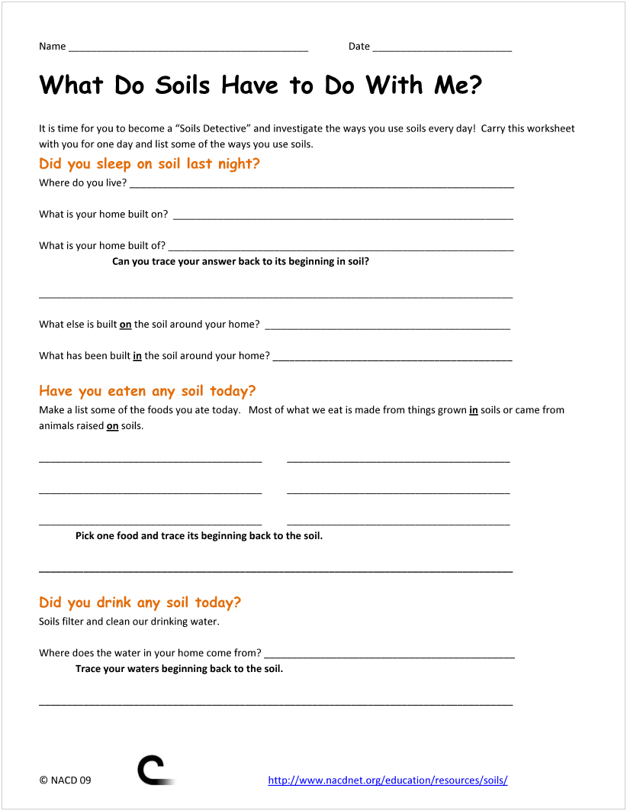
What do plants need?
Name:_______________________
Date: _____________

Write below what plants need to grow in soil:
___________________________________________________________________________________________________________________________________________________________
Components of Soil
Name: ______________________
Date: ____________
Circle below the components needed to make plants grow, put an X through things that do not make plants grow:
Organic Matter Soda pop Seeds Inorganic Matter Air Plastic People Water Clay Loamy Soil Sugar Cardboard Microorganisms Sandy soil
Rainbow Sun Wind

Living, Non-living and Once living Components

Name ______________________________ Date:_________

What is in Soil?
Activity 1: Soil Inventory
Use a magnifying glass and tweezers to examine a small sample of garden soil.
Look for: mineral matter - small pieces of rocks and minerals (the chunks you can’t easily break) organic matter - leaves, sticks, insect parts (legs, antennas, etc.), living insects and worms
Make a list under each heading of what you found:
Living and Once Living Organisms Nonliving (rocks and minerals)
__________________________________________________________________________________________________________
__________________________________________________________________________________________________________
__________________________________________________________________________________________________________
__________________________________________________________________________________________________________
__________________________________________________________________________________________________________
____________________________________________________________________________________________________________________________________________________________________________________________________________________
What is Erosion?
Name:_______________________
Date: ____________
What is erosion and why does it happen?
___________________________________________________________________________________________________________________________________________________________
Illustration of Erosion
Name:_____________ Date:________
Draw an illustration of erosion below:

The Characteristics of Soil
Name:_________________________
Date: _____________
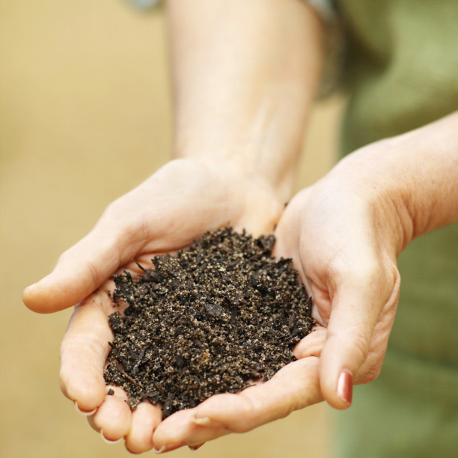
Compare and contrast the physical characteristics of the three different types of soil: Clay, Humous, and Sand
Compare: Contrast:
_____________________________________________________________________________________________________________________________________________________________________________________________________________
Soil across Landscapes
Name:__________________________
Date: ___________________
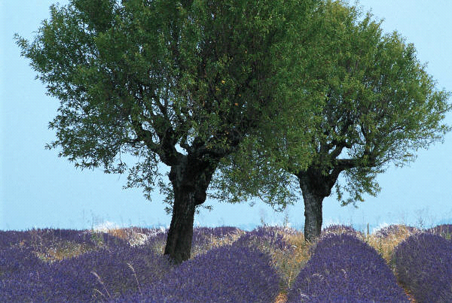
Analyze landscapes and write down the different soil characteristics
Landscape type | Soil characteristics

How do plants help erosion?
Name:__________________________
Date: ______________
Go outside and examine how erosion helps plants then journal it:
_________________________________________________________________________________________________________________________________________________________________________________________
Erosion Observation
Name:__________________________
Date:_____________
Observe erosion and records its effects:
_______________________________________________________________________________________________________________________________________________________________________________________________________________________________________
Name:_______________________
Date: ____________
Observe and record your plant growth in different soils:
____________________________________________________________________________________________________________________________________________________________________________________________________________________________________________________________________________________________________________________________________________________________________________________________________________________________________________________________________________________________________________________________________________________________________________________________________________________________________________________________________________________________________________________________________________________________________________________________________________________________________________________________________________________________________
Name:_______________________
Date: ____________
Observe and record your plant growth in items other than soil:
____________________________________________________________________________________________________________________________________________________________________________________________________________________________________________________________________________________________________________________________________________________________________________________________________________________________________________________________________________________________________________________________________________________________________________________________________________________________________________________________________________________________________________________________________________________________________________________________________________________________________________________________________________________________________
Name:_______________________
Date: ____________
Observe and record the effects on your tray with little water:
____________________________________________________________________________________________________________________________Record the effects on your tray with a large amount of water: __________________________________________________________________________________________________________________________________________________________________________________________

